REVAN INFLUENCE DIAGRAM
USER MANUAL

TABLE OF CONTENTS

CHAPTER 1. REVAN INFLUENCE DIAGRAM USER INTERFACE 1
User Interface Overview 1
Toolbar Panel 1
Components Panel 2
Canvas 2
Outline Panel 2
Properties Panel 2
CHAPTER 2. EXPRESSION 4
Tokens 4
Predefined constants 4
Operators 5
Builtin Functions 6
Variables and Expression Linking 7
CHAPTER 3. COMPONENTS 9
1. Expression Component 9
2. Spreadsheet Component 9
2.1. Spreadsheet Column and Row Common Expression 10
2.2. Range Selection 11
2.3. Exporting to Excel 11
3. Macro component 11
3.1. Including External Macro 12
4. Mindmap Component 13
5. Conditional Component 13
6. Loop Component 14
CHAPTER 4. MISCELLANEOUS FUNCTIONS 15
Export as Image 15
Goal Seek 15
Data Table 15

CHAPTER 1. REVAN INFLUENCE DIAGRAM USER INTERFACE

User Interface Overview

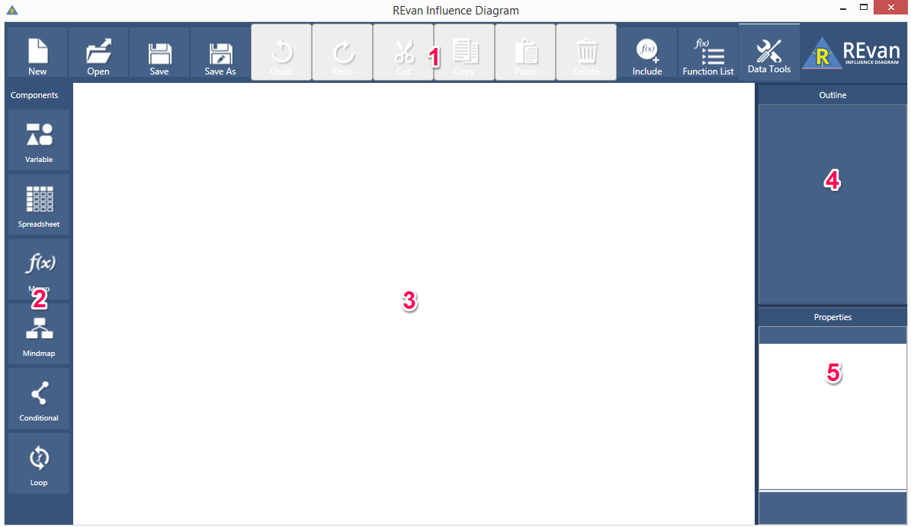

- Toolbar panel. Contain the system menu and miscellaneous functionality.
- Components panel. Contain thumbnails to insert a new component to the canvas.
- Canvas. The main working area.
- Outline panel. Display list of components that have been added to the canvas.
- Properties panel. Display properties of currently focused component.

Toolbar Panel
- New. Create new worksheet on separate window application.
- Open. Open a saved worksheet.
- Save. Save current worksheet.
- Save As. Save current worksheet to a new file.
- Undo. Cancel previous action.
- Redo. Reapply previous action that has been cancelled by Undo command.
- Cut. Copy and delete currently selected component/text.
- Copy. Save currently selected component/text into clipboard.
- Paste. Insert component/text in the clipboard.
- Delete. Remove currently selected component/text.
- Include Macros. Include macros from external worksheet.
- Function List. Open a window that lists all builtin functions and user defined functions.
- Data Tools. Open the data tools dropdown.

Components Panel
Click and drag a component from the component thumbnail to the canvas area to insert it.
More detail on each component is explained in Chapter 3.

Canvas
The main working area. Components will be inserted here.
Besides the components panel, another way to insert component is right click on an empty area on the canvas to open context menu and choose a new component.
When the components exceed canvas area, scrollbar(s) will appear so the working area can be scrolled. Other than the scrollbar, left clicking and drag on an empty area on the canvas will also move the working area.
To zoom in/out on the canvas, hold Ctrl button and scroll the mouse wheel up/down. Other than that, pressing Ctrl+plus(+) will do zoom in incrementally, Ctrl+minus(-) will do zoom out, and Ctrl+zero(0) will reset the zoom level.

Outline Panel
Display list of components that have been added to the canvas.
Left clicking on an item on the outline panel will automatically select the actual component and display its properties on the Properties Panel.

Properties Panel
Display properties of currently focused component. Some of the properties are:
- Label. The component label, default is empty. When set, a label box will appear on top of the component UI and the Outline Panel will display the label instead of generic name.
- X. The component’s horizontal position.
- Y. The component’s vertical position.
- Description. For Macro and Loop only. If a description is set by user, it will be displayed on the Function List window.
- Shape. For Variable and Mindmap only. Set the component’s visual shape.
- Background Color. Set the component’s background color.
- Border Color. Set the component’s border color.
- Font Color. Set the component’s font color.

CHAPTER 2. EXPRESSION

Expression in REvan Influence Diagram is a string of tokens that can be evaluated into a value, for example a mathematical formula. Tokens can be boolean, numbers, strings, predefined constants, operators, functions, and variables.
For notation, in this chapter expressions will be written enclosed by brackets, for example [1], [2], etc.

Tokens
Boolean is used in logical expression. There’s only 2 boolean values, [true] and [false]. They can be combined using logical operator, for example [true&&false] will result in boolean False, etc.
Numbers in expression is written as it is. For example expression [1] will result in the number 1, etc. Number can be written in exponent format, for example [2.5e2] = 2.5*10² = 250, or [1e-2] = 1*10⁻² = 0.01.
Strings in expression must be enclosed within a single quote. For example expression [’abc’] will result in the string ‘abc’.
Predefined constants are special string of characters that has a fixed value. In expression it is written as it is, for example [pi] will result in 3.142, etc.
Operators are special characters that operate on token on the left side and right side of it, just like mathematical operator such as plus (+), minus (-), etc. Operators in expression is written as it is, for example [1+1] will result in the number 2, [3-2] will result in the number 1, etc.
Functions are special string of characters that operate on 1 or more tokens, separated by comma. REvan Influence Diagram contains a set of predefined builtin functions, but users can define more functions by using the Macro and Loop component. Functions in expression is written in the format function_name(token1,token2,…), for example [abs(-1)] will result in the number 1, [max(1,2,3)] will result in the number 3, etc.
Variables are values derived from another expression that’s linked to the current expression. Variables can only be created by linking an expression to another expression. Variable is evaluated the same way as boolean, numbers, or strings, depending on the value it contains.

Predefined constants
REvan Influence Diagram has 2 predefined constants
- “pi”, the ratio of a circle’s circumference to its diameter. For example [cos(pi)] = -1
- “ec” for Euler’s number, the base of the natural logarithm. For example [ln(ec)] = 1
The constants are case sensitive, so [pi] is usable but not [PI].

Operators
By default, operator precedence works just like normal mathematical operator. For example, multiplication (*) has higher precedence than plus (+) so expression [1+2*2] will result in the number 5.
Parentheses can be used to change the order of operator precedence in an expression. For example, [(1+2)*3] will result in the number 9, but [1+(2*3)] will result in the number 7.
List of general operators:
Operator | Description | Example
= or == | Equality | [1==1] gives True
!= or <> | Inequality | [1!=1] gives False

List of mathematical operators:
Operator | Description | Example
+ | Addition | [1+1] gives 2
- | Subtraction | [1-1] gives 0
* | Multiplication | [2*2] gives 4
/ | Division | [3/2] gives 1.5
% | Modulus (division remainder) | [13%5] gives 3
< | Less than | [2<3] gives True
<= | Less than or equal to | [2<=2] gives True
> | Greater than | [3>2] gives True
>= | Greater than or equal to | [3>=3] gives True

List of logical operators:
Operator | Description | Example
&& | Boolean AND | [True&&False] gives False
|| | Boolean OR | [True||False] gives True
! | Boolean NOT | [!True] gives False

List of string operators:
Operator | Description | Example
+ | Concatenation | [‘ab’+’cd’] gives ‘abcd’

List of bitwise operators:
Operator | Description | Example
& | Bitwise AND | [3&0] gives 0
| | Bitwise OR | [0|7]] gives 7
^ | Bitwise XOR | [7^7] gives 0
~ | Bitwise NOT | [~1] gives -2
<< | Bitwise left shift | [8<<1] gives 16
>> | Bitwise right shift | [8>>1] gives 4

Builtin Functions
REvan Influence Diagram has a set of predefined builtin functions. The list can be read by opening the Function List window using Function List menu on the toolbar.
Function names are case insensitive, so [abs(-1)] and [ABS(-1)] can both be used. This also applies to user defined functions.
Below is the complete list.
Function | Description
abs | Absolute value
sin, cos, tan | Trigonometric functions sine, cosine, tangent
sec, csc, cot | Secant, cosecant, cotangent
asin, acos, atan | Arcsine, arccosine, arctangent
sinh, cosh, tanh | Hyperbolic sine, hyperbolic cosine, hyperbolic tangent
asinh, acosh, atanh | Arc hyperbolic sine, arc hyperbolic cosine, arc hyperbolic tangent
ceil | Ceiling value
floor | Floor value
exp | Exponential function with Euler constant as base, i.e. exp(x) = e^{x}
pow | Pow(a,b) = a to the power of b, i.e. a^{b}
pow2, pow10 | Power with base 2 and 10 respectively
ln | Logarithmic in Euler constant as base, i.e. ln(x) = ^{e}log x
log | Log(a,b) = logarithm of a in base b, i.e. ^{b}log a
log2, log10 | Logarithm in base 2 and 10 respectively
fac | Factorial
round | Rounding
sign | Returns 0, 1, or -1 depending on the parameter is zero, positive, or negative respectively
sqrt | Square root
max | Maximum of 2 parameters
min | Minimum of 2 parameters
if | If(a,b,c) = b if a is true, or c if a is false
sigma | Sigma(a,b,c) will give a sum of expression “c” iterated from a to b. The third parameter can contain a special identifier “k” which symbolizes the iterator. For example:  sigma(1,3,1) = 1 + 1 + 1 = 6  sigma(1,3,k) = 1 + 2 + 3 = 6  sigma(1,3,k*k) = 1 + 4 + 9 = 14
sum | adds all the numbers in a range of cell
average | returns the average of numbers in a range of cell
max | returns the largest number in a set of values
min | returns the smallest number in a set of values
stdev | estimates standard deviation based on a sample
count | count the number of cells that contains number
mode | returns the most frequently occuring value in a range of data
median | returns the median of the set of given numbers
rand | returns a random number between 0.0 and 1.0
Irr | returns the internal rate of return for a series of cashflow
npv | returns the net present value of an investment based on a discount rate and a series of future payments (negative values) and income (positive values)
sln | returns the straight-line depreciation of an asset for one period
vdb | returns the depreciation of an asset for any period you specify, including partial periods, using the double-declining balance method or some other method you specify
pmt | calculates the payment for a loan based on constant payments and a constant interest rate
rate | returns the interest rate per period of a loan or an investment
pv | returns the present value of an investment
fv | returns the future value of an investment
hlookup | looks for a value in the top row of a table and returns the value in the same column from a row you specify
vlookup | looks for a value in the leftmost column of a table and returns the value in the same row from a column you specify
or | checks whether any of the arguments are TRUE, and returns FALSE only if all arguments are FALSE
and | checks whether all arguments are TRUE, and returns TRUE if all arguments are TRUE
Note: All trigonometric functions work in radiant, not degrees.
Builtin functions that receive exactly 1 spreadsheet range parameter (explained more in Spreadsheet Component part) can also receive unlimited parameters that will be treated as a range. For example, the function Min can be used with range like [min(A1:A3)] or used with parameters like [min(1,2,3,4,5)].

Variables and Expression Linking
Variables are values derived from another expression that’s linked to the current expression. To create a variable, an expression must be linked to another expression. Linking can be done in 2 steps.
- Click to focus on an expression and make sure the text editor appears.
- Click on another expression. A box will appear as the variable marker, and an arrow will appear showing the link between the 2 expressions.
Linking 2 expressions will create a dependency between them. Changing one expression will automatically change other expression that’s linked to it.
For example, as in the image below component “b” has expression [2], component “a” is linked to “b” with expression [<b>+3]. If expression in “b” is changed, the value of “a” will also change accordingly.
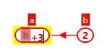
As a rule, circular linking cannot occur. As example in the image above, if we focus on component “b” and click component “a”, nothing will happen because “a” is already linked to “b”, hence “b” cannot be linked to “a”. This circular linking rule also applies in 3 components, 4 components, and so on.

CHAPTER 3. COMPONENTS

To add a component to the canvas, do one of the following:
- drag the component thumbnail from left bar to the canvas, or
- right click the canvas and choose the component name from context menu
To move the component on the canvas, click and hold left mouse button on the component and drag it.
To delete a component, do one of the following:
- click the component to focus on it and press DELETE key, or
- right click on the component and choose “Delete” from context menu
There are 6 types of components available, they are:
- Expression component.
- Spreadsheet component.
- Macro component.
- Mindmap component.
- Conditional component.
- Loop component.
More explanation will be given below for each component.

Expression Component
Basic component that can contain exactly 1 expression.
Following are actions that can be done with Expression component.
- Click on the component to put it into focus, a cursor will appear inside
- Type on the textbox to set expression. To finish, press ENTER key or remove the focus from the component (by clicking on any blank area on the canvas)
- To link to expression on other component(s), while in focus, click on the other component. The linked expression will appear in red box.

Spreadsheet Component
Spreadsheet component contains multiple expressions, arranged in rows and columns.
Following are actions that can be done with Spreadsheet component.
- Click twice on a cell to put the cell into focus. The cell behaves similar to a single Expression Component. We can put expression into it and link the expression to another cell or other Expression Component.
- Click on the top right box to add a new column, and the left bottom box to add a new row.
- Double click on the column/row header (the gray box on topmost and leftmost) to change the column/row label.
- Right click on the column/row header to open context menu. Context menu allows to insert new column/row in the middle, delete column/row, change the column/row label, and set the column/row common expression.

Spreadsheet Column and Row Common Expression
We can set a common expression that applies to all cells in a spreadsheet column. To do this, right click on the column header to open context menu then select “Expression”. The header will change into a textbox where we can input the expression. Note that when we assign a column expression, the cells will be greyed out and cannot be edited anymore. To edit the cells individually, remove the column expression by inputting blank value.
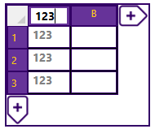
The column expression can link to other components just like any other expression component (an exception is linking to its own cell members because it will create cyclic dependency).
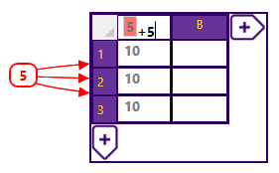
Other than that, column expression can link to another column in the same spreadsheet. When this is done, the cells will link to the corresponding rows on the linked column. This is useful to create a column that calculates value from other columns.
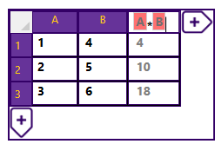
For setting row common expression, use the spreadsheet row header in the same way.

Range Selection
Cells inside a spreadsheet component can be multi-selected in a rectangular shape to make a range selection. The range can be used as input for functions that accepts range as its input. To select range of cells, click and drag the mouse over the cells.
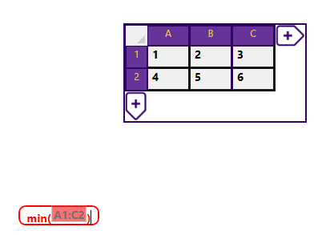

Exporting to Excel
Spreadsheet component can be exported into an Excel workbook (.xlsx or .xls format). To do this, right click on the spreadsheet component to open context menu and choose “Export to Excel”.

Macro component
Macro component is used to make user defined function.
A macro consists of 3 parts: the macro name, macro parameters, and macro expression. Name can be changed to define what function name will be used to call the macro. Parameters can be added, renamed, or removed. Expression works in similar way to Expression component and Spreadsheet component cells.
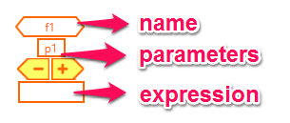
- To define a macro, adjust the number of parameters and assign the calculation into the expression textbox. The expression can be linked to the parameter textbox to define the macro in term of its parameters.
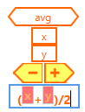
- After defined, the macro can be used the same way as builtin functions.
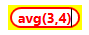
- Macro name is case insensitive

Including External Macro
A worksheet can use macros from another worksheet using the “Include External Macro” functionality. To use it, click on menu “Include” on the toolbar. If the current worksheet has not been saved, it needs to be saved first because the included macros will be referenced by relative path to the current worksheet. A dialog will open and we can add one or more .ind files to be included to the current worksheet. Now macros from included worksheet can be used the same way as internal macros.
When we save the current worksheet, reference to external worksheet will be saved too. Next time we open the worksheet, the external macros will be automatically loaded. Because the external worksheets are saved as relative path to the current worksheet, make sure to keep all files together when moving them to another folder.

Mindmap Component
Mindmap component is the simplest component that contains only a label. Mindmap will not evaluate any expression and thus cannot be linked to other types of component. But a Mindmap component can be connected to other Mindmap component to create visual connection. This is done the same way as linking expression, by focusing on a Mindmap component and click on another one.
Circular connection in Mindmap components is possible because the connection is only visual, not a logical one.
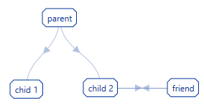
The created connection can be removed by clicking on the connection arrow and pressing Delete, or right click the arrow to bring up context menu and choose Delete.

Conditional Component
Conditional component works like builtin function IF. It contains 3 expressions: the condition expression, the true expression, and the false expression. It works by first evaluating the condition expression. If the condition expression value is true, the component will use value from the true expression, otherwise value from the false expression is used.
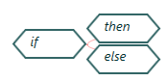
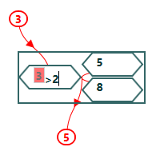

Loop Component
Loop component is a specialized type of Macro Component. Just like Macro component, it is used to make a user defined function.
Loop component consists of name, conditional expression, result expression, and 1 or more pair of parameter-iterator expression.
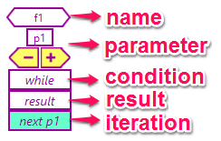
It works according to following algorithm:
- Define parameter with passed value. For example, f(5) will define parameter p1 with value 5.
- While (conditional expression) evaluates to true, evaluate iterator expressions and substitute it to parameter values one by one.
- Return result expression.
To prevent infinite loop that can occur when the conditional parameter always evaluate to True, the loop evaluation has a time limit of 1 second. After 1 second, the execution is terminated and the result value is Error.
For example, the following component defines function sigma2(x) as sum of 1+2+…+x
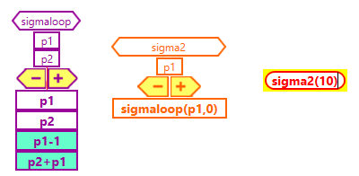

CHAPTER 4. MISCELLANEOUS FUNCTIONS

Export as Image
The diagram canvas can be exported as image in PNG format. To do this, use menu “Save As” on the toolbar and choose “Image File (.png)” in “Save as type” option.

Goal Seek
Goal Seek is used to find value for an expression that is used as a variable by another expression, to approximate result of the dependent expression to a certain value. For example suppose there is an expression “a” = [<b>*<b>], and we want to find value of “b” that approximates value of “a” to 25. We can use Goal Seek to find it.
Goal Seek feature is placed on the menu “Data Tools” on the Toolbar. It works by guessing the value of a variable to get another expression as near as possible to a certain value. The current value of the base variable will be used as initial guess if it is set, otherwise 0 will be used as initial guess.
The expected value may not be found if the expression does not converge. In that case the algorithm will stop after some amount of iterations.
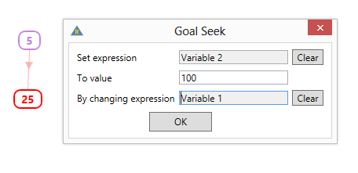

Data Table
Data Table is a way to automatically assign values of cells in a Spreadsheet according to some formula and dependent on values in topmost or leftmost cells, or both.
Data Table menu is placed on the menu “Data Tools” on the Toolbar. Data Table works by substituting a variable with a list of values to get a list of result based on different input value. To use the Data Table menu, user needs to select a spreadsheet range with minimum size 2x2 then click the menu.
There are 3 possible way to use a Data Table: column only, row only, and row + column (2 variables)
With a column only Data Table, the evaluated expression needs to be set on the first row, second column cell. The input values are set on the first column from second row to last row, like the following.
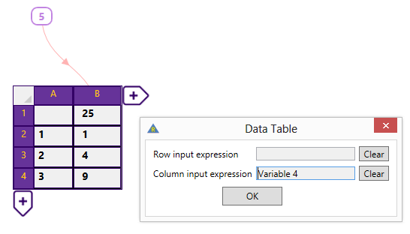
With a row only Data Table, the evaluated expression needs to be set on the first column, second row cell. The input values are set on the first row from second column to last column, the the following.
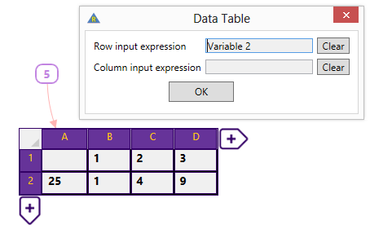
With a Data Table that use both row and column (2 variables), the evaluated expression needs to be set on first column, first row. The input values are set on the first column and first row for the column variable and row variable respectively.
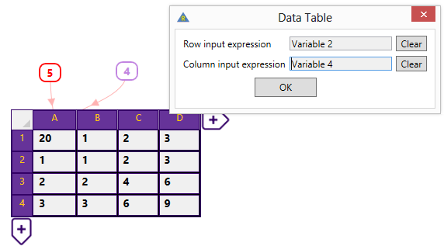
A Data Table will lock a region in the spreadsheet. The range included in the Data Table cannot be modifed by adding/deleting the column/row between it.
The Data Table cannot be removed partially. To completely remove a Data Table, click on any of the cell and press Delete. A confirmation dialog to remove the entire Data Table will appear.

